Quick pickles

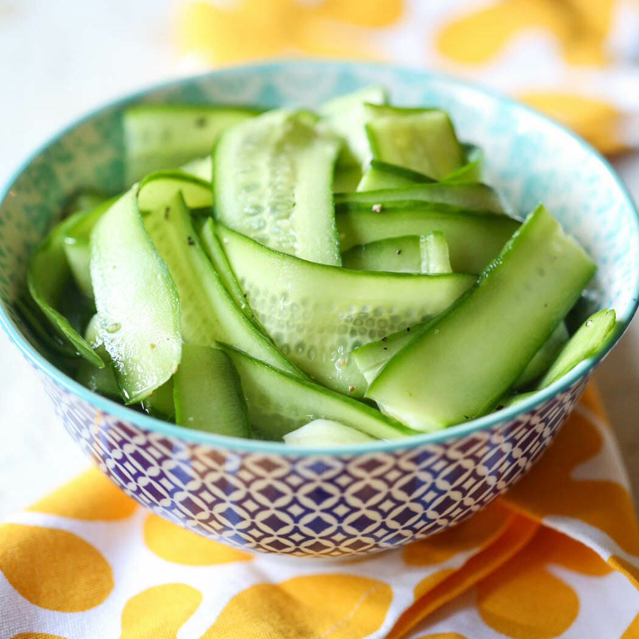

* ¾ cup white wine vinegar
* ¼ cup water
* 2 tbsp chopped dill
* 1 clove garlic, crushed
* ½ tsp salt
* 1 medium cucumber

1. Combine all ingredients except cucumber into saucepan. Heat for 2 min to dissolve. Remove from heat.
2. Thinly slice cucumber. Add to brine and set aside.